OS Lab Assignment 5

## Name: Keshav Garg

## ID: 2018UCP1674

GitHub Repo link: [**link**](https://github.com/gargk747/OS-Lab/tree/master/Assignment%205)

**Dekker’s Algorithm (Two Processes):**

#include <stdio.h>

#include <stdlib.h>

#include <unistd.h>

#include <time.h>

#include <sys/shm.h>

#include <sys/wait.h>

int shmID, shrID, shrID2, fav;

key_t key1 = 54991, key2 = 784519, key3 = 882363, key4 = 23456;

int *p1_wants_to_enter,*p2_wants_to_enter, *shared,*favored;

int main(){

shmID = shmget(key1, sizeof(int), IPC_CREAT | 0660);

if(shmID < 0){

printf("Shared memory 1 could not be allocated\n");

exit(1);

}

shrID = shmget(key2, sizeof(int), IPC_CREAT | 0660);

if(shrID < 0){

printf("Shared memory 2 could not be allocated\n");

exit(1);

}

shrID2 = shmget(key3, sizeof(int), IPC_CREAT | 0660);

if(shrID < 0){

printf("Shared memory 3 could not be allocated\n");

exit(1);

}

fav = shmget(key4, sizeof(int), IPC_CREAT | 0660);

if(fav < 0){

printf("Shared memory 4 could not be allocated\n");

exit(1);

}

p1_wants_to_enter = (int *)shmat(shmID, NULL, 0);

favored= (int *)shmat(fav, NULL, 0);

if (p1_wants_to_enter == (int *)-1 ) {

printf("Failed to attach p1_wants_to_enter to first process\n");

exit(-1);

}

p2_wants_to_enter = (int *)shmat(shrID2, NULL, 0);

if (p2_wants_to_enter== (int *)-1 ) {

printf("Failed to attach p2_wants_to_enter to first process\n");

exit(-1);

}

shared = (int *)shmat(shrID, NULL, 0);

if (shared == (int *)-1 ) {

printf("Failed to attach shared to first process\n");

exit(-1);

}

if (favored == (int *)-1 ) {

printf("Failed to attach favoured to first process\n");

exit(-1);

}

*shared = 1;

*p1_wants_to_enter = 0;

*p2_wants_to_enter = 0;

*favored=1;

if (fork() == 0) {

srand(time(0));

p1_wants_to_enter = (int *)shmat(shmID, NULL, 0);

p2_wants_to_enter = (int *)shmat(shrID2, NULL, 0);

favored=(int *)shmat(fav, NULL, 0);

shared = (int *)shmat(shrID, NULL, 0);

if (p1_wants_to_enter == (int *)-1 ){

printf("Failed to attach p1_wants_to_enter to first process\n");

exit(-1);

}

if (p2_wants_to_enter == (int *)-1 ){

printf("Failed to attach p2_wants_to_enter to first process\n");

exit(-1);

}

if (favored == (int *)-1 ){

printf("Failed to attach favored to first process\n");

exit(-1);

}

if (shared == (int *)-1 ){

printf("Failed to attach shared variable to first process\n");

exit(-1);

}

int done=0;

for(done=0;done<=15;done++){

*p1_wants_to_enter=1;

while(*p2_wants_to_enter == 1){

if(*favored == 2){

*p1_wants_to_enter = 0;

while(*favored == 2);

*p1_wants_to_enter = 1;

}

}

*shared+=10;

printf("Process 1: %d\n",*shared);

*favored = 2;

*p1_wants_to_enter = 0;

}

}

else {

if (fork() == 0){

srand(time(0));

p1_wants_to_enter = (int *)shmat(shmID, NULL, 0);

p2_wants_to_enter = (int *)shmat(shrID2, NULL, 0);

favored=(int *)shmat(fav, NULL, 0);

shared = (int *)shmat(shrID, NULL, 0);

if (p1_wants_to_enter == (int *)-1 ){

printf("Failed to attach p1_wants_to_enter to first process\n");

exit(-1);

}

if (p2_wants_to_enter == (int *)-1 ){

printf("Failed to attach p2_wants_to_enter to first process\n");

exit(-1);

}

if (favored == (int *)-1 ){

printf("Failed to attach favored to first process\n");

exit(-1);

}

if (shared == (int *)-1 ){

printf("Failed to attach shared variable to first process\n");

exit(-1);

}

int done=0;

for(done=0;done<=15;done++){

*p2_wants_to_enter=1;

while(*p1_wants_to_enter == 1){

if(*favored == 1){

*p2_wants_to_enter = 0;

while(*favored == 1);

*p2_wants_to_enter = 1;

}

}

*shared+=15;

printf("Process 2: %d\n",*shared);

*favored = 1;

*p2_wants_to_enter = 0;

}

}

else{

sleep(1);

wait(NULL);

wait(NULL);

}

}

}

**Output:**

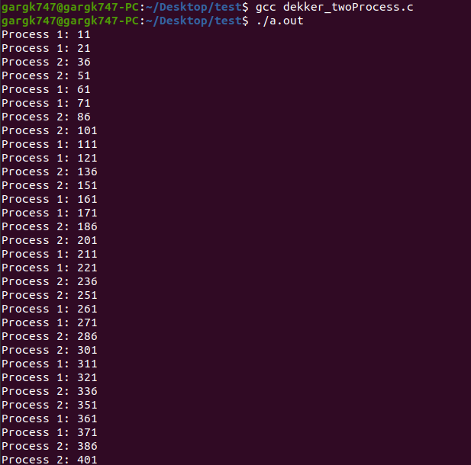

**Peterson’s Algorithm (Two Processes):**

#include <stdio.h>

#include <stdlib.h>

#include <unistd.h>

#include <time.h>

#include <sys/shm.h>

#include <sys/wait.h>

int shmID, shrID, shrID2, fav;

key_t key1 = 54991, key2 = 784519, key3 = 882363, key4 = 23456;

int *p1_wants_to_enter,*p2_wants_to_enter, *shared,*favored;

int main(){

shmID = shmget(key1, sizeof(int), IPC_CREAT | 0660);

if(shmID < 0){

printf("Shared memory 1 could not be allocated\n");

exit(1);

}

shrID = shmget(key2, sizeof(int), IPC_CREAT | 0660);

if(shrID < 0){

printf("Shared memory 2 could not be allocated\n");

exit(1);

}

shrID2 = shmget(key3, sizeof(int), IPC_CREAT | 0660);

if(shrID < 0){

printf("Shared memory 3 could not be allocated\n");

exit(1);

}

fav = shmget(key4, sizeof(int), IPC_CREAT | 0660);

if(fav < 0){

printf("Shared memory 4 could not be allocated\n");

exit(1);

}

p1_wants_to_enter = (int *)shmat(shmID, NULL, 0);

favored= (int *)shmat(fav, NULL, 0);

if (p1_wants_to_enter == (int *)-1 ) {

printf("Failed to attach p1_wants_to_enter to first process\n");

exit(-1);

}

p2_wants_to_enter = (int *)shmat(shrID2, NULL, 0);

if (p2_wants_to_enter== (int *)-1 ) {

printf("Failed to attach p2_wants_to_enter to first process\n");

exit(-1);

}

shared = (int *)shmat(shrID, NULL, 0);

if (shared == (int *)-1 ) {

printf("Failed to attach shared to first process\n");

exit(-1);

}

if (favored == (int *)-1 ) {

printf("Failed to attach favoured to first process\n");

exit(-1);

}

*shared = 1;

*p1_wants_to_enter = 0;

*p2_wants_to_enter = 0;

*favored=1;

if (fork() == 0) {

srand(time(0));

p1_wants_to_enter = (int *)shmat(shmID, NULL, 0);

p2_wants_to_enter = (int *)shmat(shrID2, NULL, 0);

favored=(int *)shmat(fav, NULL, 0);

shared = (int *)shmat(shrID, NULL, 0);

if (p1_wants_to_enter == (int *)-1 ){

printf("Failed to attach p1_wants_to_enter to first process\n");

exit(-1);

}

if (p2_wants_to_enter == (int *)-1 ){

printf("Failed to attach p2_wants_to_enter to first process\n");

exit(-1);

}

if (favored == (int *)-1 ){

printf("Failed to attach favored to first process\n");

exit(-1);

}

if (shared == (int *)-1 ){

printf("Failed to attach shared variable to first process\n");

exit(-1);

}

int done=0;

for(done=0;done<=15;done++){

*p1_wants_to_enter=1;

*favored=1;

while(*p2_wants_to_enter && (*favored==2));

*shared+=10;

printf("Process 1: %d\n",*shared);

*p1_wants_to_enter=0;

}

}

else {

if (fork() == 0){

srand(time(0));

p1_wants_to_enter = (int *)shmat(shmID, NULL, 0);

p2_wants_to_enter = (int *)shmat(shrID2, NULL, 0);

favored=(int *)shmat(fav, NULL, 0);

shared = (int *)shmat(shrID, NULL, 0);

if (p1_wants_to_enter == (int *)-1 ){

printf("Failed to attach p1_wants_to_enter to first process\n");

exit(-1);

}

if (p2_wants_to_enter == (int *)-1 ){

printf("Failed to attach p2_wants_to_enter to first process\n");

exit(-1);

}

if (favored == (int *)-1 ){

printf("Failed to attach favored to first process\n");

exit(-1);

}

if (shared == (int *)-1 ){

printf("Failed to attach shared variable to first process\n");

exit(-1);

}

int done=0;

for(done=0;done<=15;done++){

*p2_wants_to_enter=1;

*favored=2;

while(*p2_wants_to_enter && (*favored==1));

*shared+=15;

printf("Process 2: %d\n",*shared);

*p2_wants_to_enter=0;

}

}

else{

sleep(1);

wait(NULL);

wait(NULL);

}

}

}

**Output:**

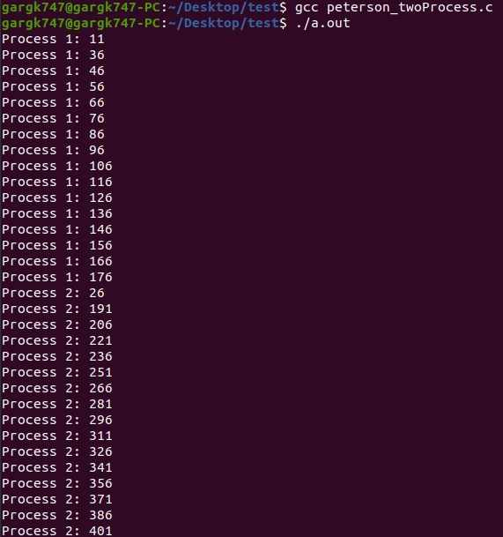

**Dekker’s Algorithm (Two Threads):**

// gcc -pthread <name.c>

// This program creates two threads, each thread

#include <stdio.h>

#include <stdlib.h>

#include <unistd.h>

#include <pthread.h>

int x = 0; // Shared variable

#define THREAD1 0

#define THREAD2 1

#define TRUE 1

#define FALSE 0

int p1_wantstoenter;

int p2_wantstoenter;

int favouredProcess;

void Initialization(void) {

p1_wantstoenter=0;

p2_wantstoenter=0;

favouredProcess=1;

srand(time(NULL));

}

void *func1(void *s) {

int i, k;

for (i=0; i < 5; i++) {

p1_wantstoenter=1;

while(p2_wantstoenter)

{

if(favouredProcess==2)

{

p1_wantstoenter=0;

while(favouredProcess==2)

;

p1_wantstoenter=1;

}

}

// Critical Section - shared variable is incremented

x = x+1;

printf("[%2d] : Thread 1 in Critical Section (%d).\n", i+1,x);

favouredProcess=2;

p1_wantstoenter=0;

// Random delay added

k = (int) ((3.0*rand())/RAND_MAX);

sleep(k);

}

}

void *func2(void *s) {

int i, k;

for (i=0; i < 5; i++) {

p2_wantstoenter=1;

while(p1_wantstoenter)

{

if(favouredProcess==1)

{

p2_wantstoenter=0;

while(favouredProcess==1)

;

p2_wantstoenter=1;

}

}

// Critical Section - shared variable is incremented

x = x+1;

printf("[%2d] : Thread 2 in Critical Section (%d).\n", i+1,x);

favouredProcess=1;

p2_wantstoenter=0;

// Random delay added

k = (int) ((5.0*rand())/RAND_MAX);

sleep(k);

}

}

int main() {

pthread_t Thread1, Thread2;

// Initialized the lock then fork 2 threads

Initialization();

// Create two threads (both run func)

pthread_create(&Thread1, NULL, func1, (void *) THREAD1);

pthread_create(&Thread2, NULL, func2, (void *) THREAD2);

// Wait for the threads to end.

pthread_join(Thread1, NULL);

pthread_join(Thread2, NULL);

return 0;

}

**Output:**

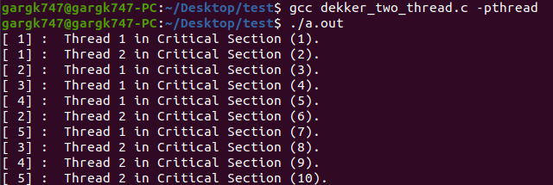

**Peterson’s Algorithm (Two Threads):**

// gcc -pthread <name.c>

// This program creates two threads, each thread

#include <stdio.h>

#include <stdlib.h>

#include <unistd.h>

#include <pthread.h>

int x = 0; // Shared variable

#define THREAD1 0

#define THREAD2 1

#define TRUE 1

#define FALSE 0

int p1_wantstoenter;

int p2_wantstoenter;

int favouredProcess;

void Initialization(void) {

p1_wantstoenter=0;

p2_wantstoenter=0;

favouredProcess=1;

srand(time(NULL));

}

void *func1(void *s) {

int i, k;

for (i=0; i < 5; i++) {

p1_wantstoenter=1;

favouredProcess=2;

while(p2_wantstoenter && favouredProcess==2)

;

// Critical Section - shared variable is incremented

x = x+1;

printf("[%2d] : Thread 1 in Critical Section (%d).\n", i+1,x);

p1_wantstoenter=0;

// Random delay added

k = (int) ((3.0*rand())/RAND_MAX);

sleep(k);

}

}

void *func2(void *s) {

int i, k;

for (i=0; i < 5; i++) {

p2_wantstoenter=1;

while(p1_wantstoenter && favouredProcess==2)

;

// Critical Section - shared variable is incremented

x = x+1;

printf("[%2d] : Thread 2 in Critical Section (%d).\n", i+1,x);

favouredProcess=1;

p2_wantstoenter=0;

// Random delay added

//k = (int) ((5.0*rand())/RAND_MAX);

sleep(k);

}

}

int main() {

pthread_t Thread1, Thread2;

// Initialized the lock then fork 2 threads

Initialization();

// Create two threads (both run func)

pthread_create(&Thread1, NULL, func1, (void *) THREAD1);

pthread_create(&Thread2, NULL, func2, (void *) THREAD2);

// Wait for the threads to end.

pthread_join(Thread1, NULL);

pthread_join(Thread2, NULL);

return 0;

}

**Output:**

